**Module 2 Mastery Assessment**

SS1: Guest WIFI Basic Setup

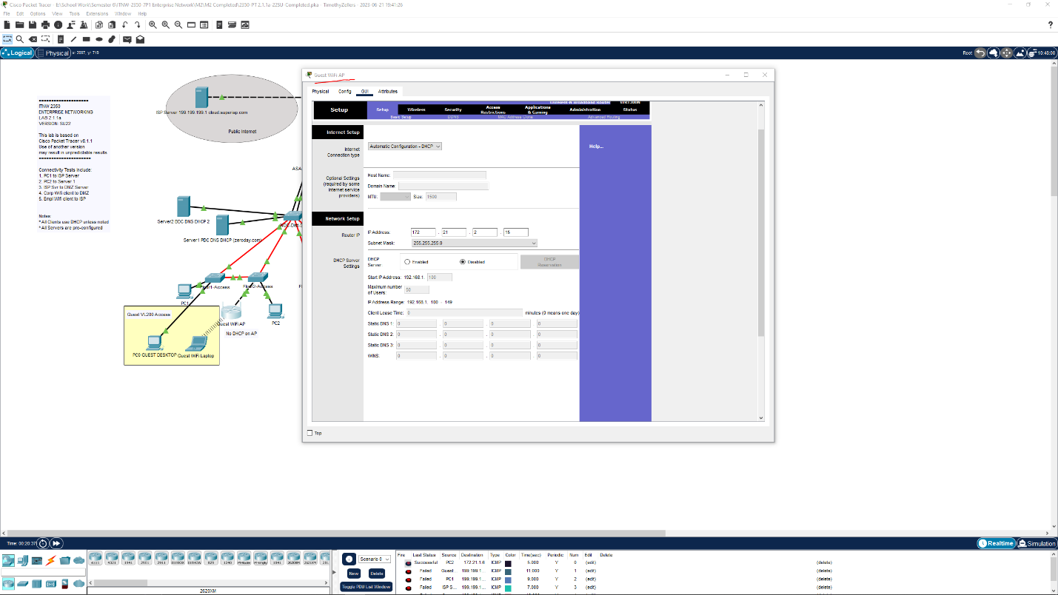

SS2: Guest Wireless Setup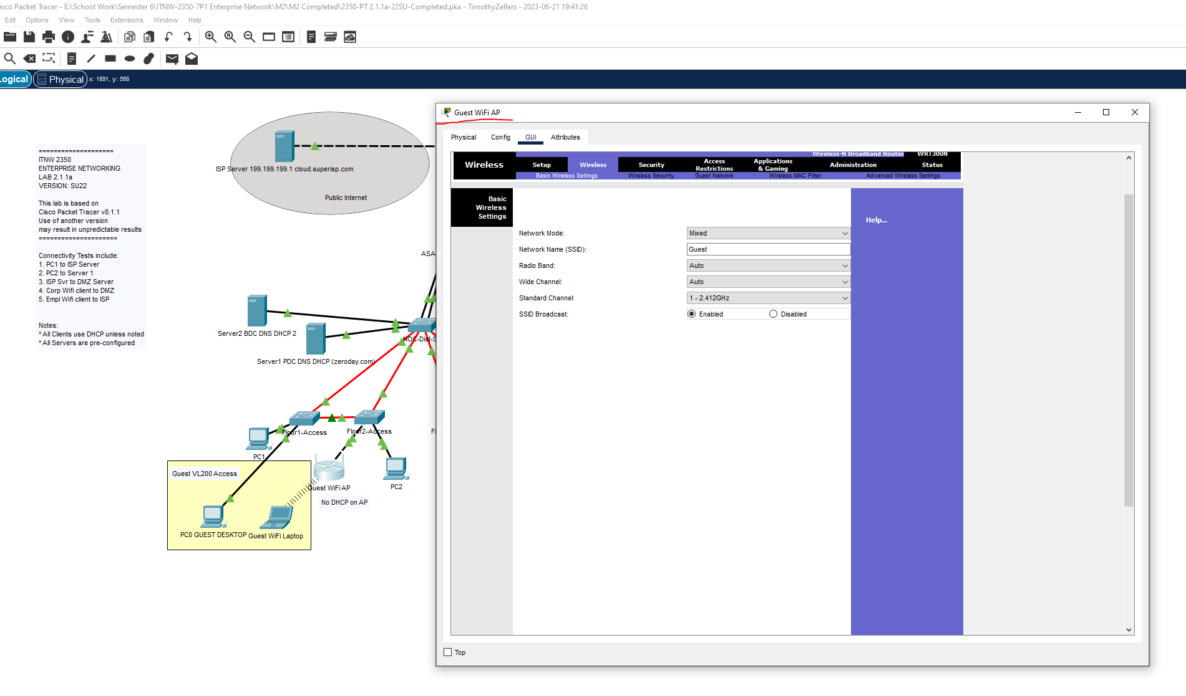

SS3: Employee Basic Setup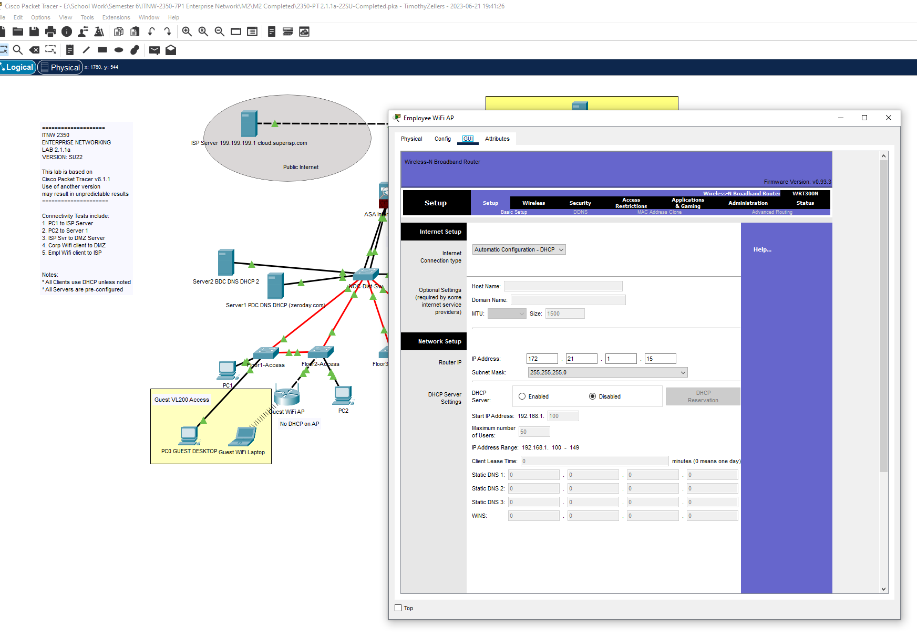

SS4: Employee Wireless Setup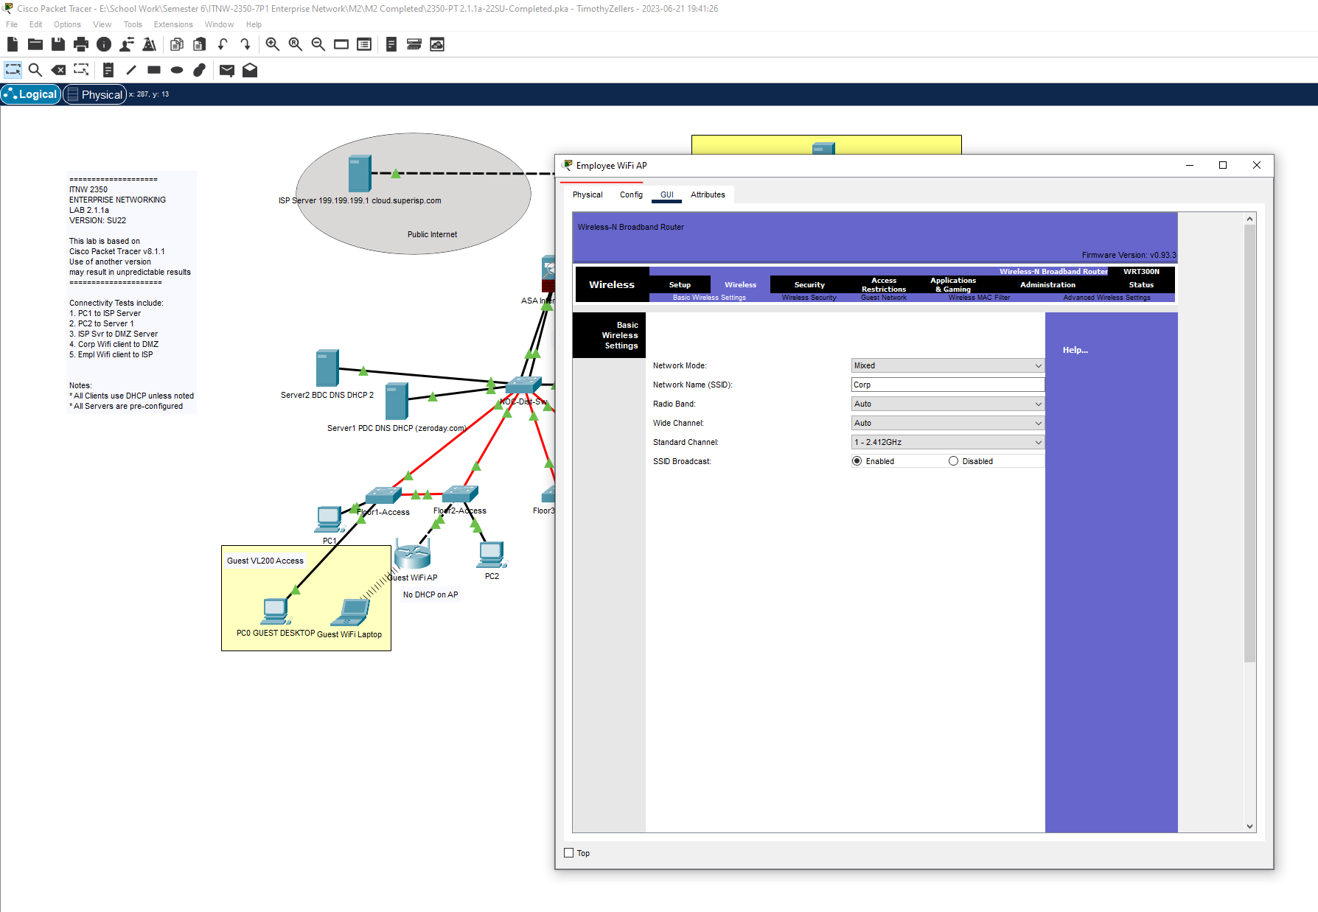

SS5: Employee Wireless Security Settings